Frozen Passage – Key Stage 3

Take a look at Road de-icers

Introduction
These activities allow students to model and evaluate the use of de-icers on roads. Students select de-icers for use in some sensitive locations.
Aimed at students aged 12 -14 years old, materials provide a focus for planning and carrying out science based activities. They can be used in their entirety, or activities can be selected to support another teaching programme. Teachers will find the ideas adaptable for other age-groups.
These activities are based on the Centre for Industry Education Collaboration’s Frozen Assets activity pack. For additional activities see www.ciec.org.uk.

What students do
Carry out practical work to model the action and the environmental impact of different de-icers. The performance of de-icers and their effect on road-side plants and the structural integrity of bridges and tunnels are considered.
Make decisions about the choice of de-icers in sensitive locations.
Plan additional investigations that would be necessary to collect further evidence.

Key concepts:
- Salts and the lowering of freezing point
- Osmosis
- Corrosion
- Environmental auditing

Resources
Calcium magnesium acetate (CMA) road de-icer can be obtained from on-line suppliers. A class of 30 students will use approximately 100g of CMA.
Red onions are required to study the effects of osmosis on plant cells. Three or four are sufficient for a class of 30 students.
A materials list is supplied with each activity.

Safety note
A full risk assessment, incorporating any school or local policies, should be performed before carrying out practical activities.

Introduction to the activities
This unit includes an evaluation of two de-icers:
- Rock salt
- CMA (calcium magnesium ethanoate - formerly calcium magnesium acetate)
CMA is marketed as a 'greener' de-icer.
There are three separate investigations:
- Effect of de-icer on steel (corrosion)
- Effect of de-icer on plant cells (osmosis)
- Comparison of melting caused by de-icers (lowering of melting point)
Teams of students make decisions about the de-icers to be used in three sensitive locations (photographs included):
- In a tree-lined city square
- At a motorway interchange
- On the roads and paths surrounding a retirement home
Students could be asked to suggest the different types of evidence and data that would be needed before deciding if one particular de-icer is safe and suitable for use in these locations. Many factors may be suggested by students. They might include:
- How well does the de-icer work?
- How much does the de-icer cost?
- Does the de-icer make the road surface slippery?
- How does the de-icer affect roadside plants?
- Will the de-icer be blown away by the wind?
- What happens when the de-icer drains into local streams and rivers?
- How will the de-icer affect the vehicles on the road?
- Will the de-icer damage the roads?
- What happens when the de-icer is stored for long periods?
- Is the de-icer easy to spread?
- Will the de-icer obscure the white lines on the road?
- How does the de-icer affect the soil structure at the roadside?
- What precautions could minimize any negative impact?
The number of different perspectives that need to be considered before well informed decisions are made could be used to convince students of the importance of team work and the need for effective reporting back by individual groups to the rest of the team.
An optional data analysis exercise is provided to complement each investigation. These sheets could be used to extend students who can cope with a more complete analysis. Students could be encouraged not to overlook options for dealing with snow and ice that do not involve the use of de-icers.

Management
One proposed structure is to divide the class into teams consisting of six to nine students. Each team sub-divides into three groups. The groups complete different investigations and are required to report back their findings to other team members. Each team then reaches a collective decision about the use of de-icers in the three locations.

De-icers: background information for teachers
Salt is widely used to help keep roads and paths free of ice and safer for travel during winter. Salt is an effective and inexpensive de-icer, but there can be drawbacks of using salt when its environmental impact is studied. Many of the 'costs' of using salt are not charged to the budget of the department responsible for de-icing the roads and for this reason the best choice of de-icer may not always be made.
Calcium magnesium acetate (CMA) is another road de-icer. It is effective and has less environmental impact. However, it is much more expensive than salt. This makes the choice of a de-icer less straightforward than it may originally seem.

De-icer | £ per tonne | Lowest operating temperature (ºC) | Chemical formula
Salt | 25 | -21 | NaCl
CMA | 600 | -21 | CaMg(OOC.CH₃)₄

The effect of de-icers on roadside plants
On a rural trunk road, most of the de-icing salt used ultimately deposits at the side of the carriageway. The salt may be scattered by poor spreading methods, but most of it is moved to the side of the road by the spray from traffic, wind or simply by de-icer draining off the road surface dissolved in rain water.
Plants growing in these roadside strips are vulnerable to damage from salt that accumulates in the soil and from airborne salt spray. The salt damage is due both to the osmotic stress caused by high concentrations of dissolved salt and to the toxicity of chloride ions, though the relative importance of these two factors differs from plant species to species.
Osmotic stress is the flow of water out of the cell sap in the vacuole, and out of the cell cytoplasm, into the more concentrated solution of salt that surrounds the plant tissue. The cell vacuole contracts dramatically as the water passes out of the cell. The ability of the plants to take up water is severely affected and the osmotic stress creates a physiological drought. Visible signs of damage include wilting. Cell damage due to osmotic stress may be permanent if contraction of the vacuole causes the cell membrane to be pulled away from the cell wall, or the cells may recover their normal function when the osmotic stress is relieved if the de-icer is washed from the soil by heavy rain. Some plants have ways of compensating for osmotic stress, making them more resistant to the effects of salt.
It is the toxicity of chloride ions that appears to be the principal cause of injury in plants suffering from salt damage. Chloride ions accumulate in the margins and tips of leaves, and also in dormant twigs and buds in late winter. Leaves of affected plants may be brown at the tips and edges. The effect of chloride ions is to upset metabolic processes, causing changes which include a decrease in growth, a delay in the flushing of buds in spring, and death of new foliage shortly after emergence in spring.
Plants vary in their sensitivity to chloride ions, but damage due to salt will be most obvious after severe winters when the rate of salt usage has been higher. In urban areas, trees may need to be replaced because of salt damage.
There are further effects of salt on the ion exchange processes that occur in soil and on the availability to plants of nutrients that are bound to soil particles.

The effect of de-icers on road structures
Damage to tunnels, bridges and elevated sections of motorway has been attributed to the use of salt as a de-icer. Dissolved salt diffuses through concrete and accelerates the corrosion of steel reinforcements. The oxidation of iron results in an expansion of the steel reinforcing rods and a consequent cracking and weakening of the structure. Regular inspections ensures that salt damage is identified and remedied.
Millions of pounds are spent each year to repair salt damage to road structures. Ironically, the time motorists save on cleared roads in winter may be countered by time in congestion when salt-damaged roads are repaired in the summer.
Delays and the increased frequency of traffic accidents, hospital admissions and fatalities at road works generate other costs that need to be considered if the true cost of using a de-icer is to be assessed.
Salt accelerates the corrosion of vehicles although modern vehicle design and the increased use of plastics can minimize the effects. There can also be an impact elsewhere in the environment when run-off from roads and motorways drains into streams and rivers. A complete evaluation of any de-icer is necessarily extensive and complex.

Activity 1: De-icers and corrosion
Practical investigations involve the use of solutions of de-icer. These solutions have a concentration that is equivalent to the annual cumulative amount of de-icer that is spread in one location during a severe winter (spreading rates of 5 kg/m²). It could be made clear to students that the effects they observe will be those corresponding to the worst possible scenario.

Materials
100 g/dm³ in distilled water of sodium chloride.
Freshly prepared CMA solution (100 g/dm³ in distilled water). It will need to be filtered to remove small amounts of insoluble material. Do not expose to air for any longer than necessary as solutions of CMA absorb carbon dioxide from the atmosphere. The resulting decrease in pH may lead to less satisfactory results if old solutions are used.
Each group will require:
- Approximately 50cm³ of each of the de-icer solutions
- Rack and 4 test tubes
- Labels or marker pen
- Samples of steel (2.5cm wire nails)
- Wash bottle containing distilled water

Which de-icer is best for use on a concrete bridge?
CMA is much more expensive than rock salt but when road repair costs and damage to plants are included, it may be more appropriate in certain circumstances than traditional rock salt.
Students are likely to decide that CMA is the best de-icer to use on bridges. However, they may also consider other options such as heating the road. The southern approaches to the St. Gothard and the Lopper tunnels in Switzerland, and the pavements in some American ski resorts, are kept free of ice by this method.

Which de-icer is best on reinforced concrete bridges?

Motorway bridges are often made from reinforced concrete. The great strength of reinforced concrete is due to steel rods inside the concrete.
De-icers can soak through the concrete and corrode the steel reinforcing rods.
If the reinforcing rods corrode, the bridge may weaken and could collapse if not repaired.

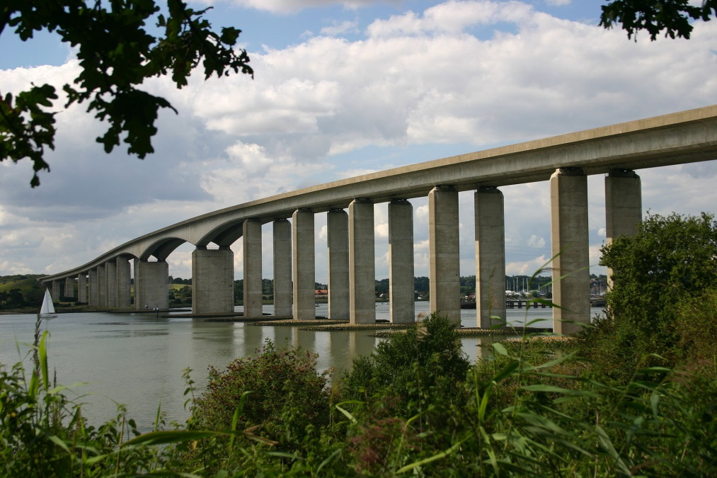
Orwell Bridge Image: Rowland Shaw, Wikimedia.

Your task
Which de-icer is best on reinforced concrete bridges?
- Test the effect of different de-icers on steel.
- Place steel nails into labelled test tubes.
- Cover the nails with solutions of de-icer. Use distilled water for the control.
- Leave the tubes for at least 24 hours.
- Observe the effect that each de-icer has had on the steel.
- Decide which de-icer to use on a motorway bridge.
- Explain your investigation and your conclusions to the rest of your team.

Activity 2: De-icers and roadside plants
Damage to road-side plants is due to osmotic stress and to the toxicity of the chemicals (particularly chlorides). Osmotic stress is investigated practically using red onion epidermis, observed under a microscope.

Materials
100 g/dm³ in distilled water of sodium chloride.
Freshly prepared CMA solution (100 g/dm³ in distilled water). It will need to be filtered to remove small amounts of insoluble material. Do not expose to air for any longer than necessary as solutions of CMA absorb carbon dioxide from the atmosphere. The resulting decrease in pH may lead to less satisfactory results if old solutions are used.
Each group will require:
- Access to red onion, scalpel and tweezers
- Approximately 5cm³ of each of the de-icer solutions
- Wash bottle containing distilled water
- dropper
- 1 x microscope
- 3 x glass microscope slide
- labels

Observations

Distilled water
The following observations should be very clear using an overall magnification of x40 and x100 (x4 and x10 objectives):
- A regular structure of identical cells that resembles a brick wall.
- The cell walls are colourless.
- The contents of each cell are uniformly pale red, though there will be slight variation between cells.
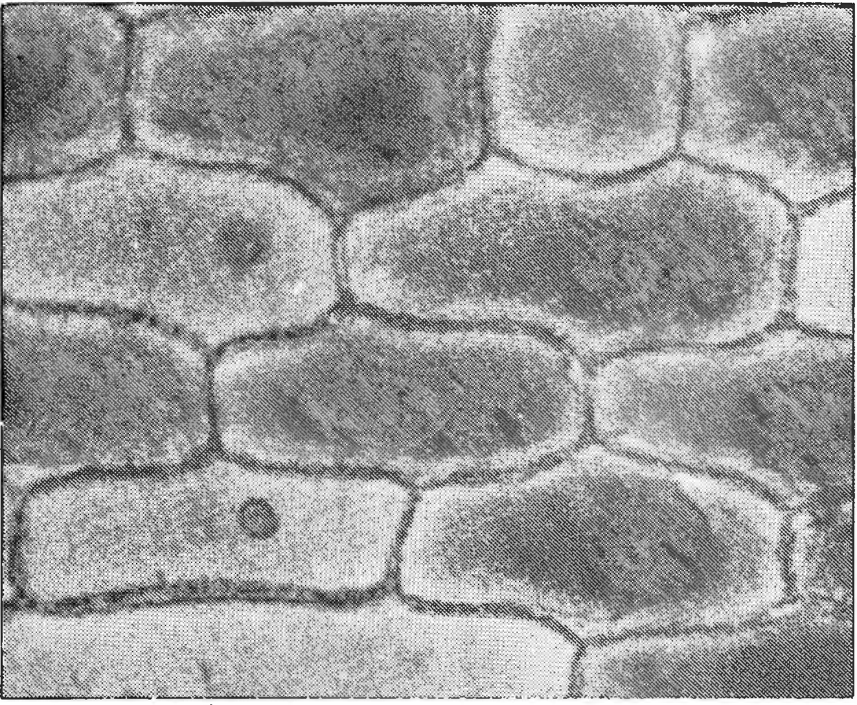
The epidermal cells from the fresh onion will be turgid (the cell vacuole will be full of red sap and will appear to occupy the entire internal volume of each cell). Neither the nucleus, nor the cytoplasm, nor the cell membrane is likely to be clearly visible. Cells that have ruptured during the preparation of the sample appear colourless.
Other layers of tissue cells may appear as a faint black latticework of colourless cells if an epidermal layer only of one cell thickness has not been obtained.

Salt solution
When salt solution is placed onto another sample of red epidermis, water passes out from the cell vacuole into the surrounding salt solution due to osmosis. The cell vacuole shrinks and can no longer contribute to the mechanical strength of the structure of the tissue. The visible result in salt-affected plants is wilting of stems. Eventually, the shrinking of the vacuole and the surrounding cytoplasm results in the cell membrane being pulled away from the cellulose cell wall (an effect called plasmolysis) and the death of the cell.
Students can observe the shrinking of the vacuole immediately the sample is viewed under the microscope. It will be complete within two or three minutes. The photographs below illustrate the effect of osmotic stress on cells of red onion.
The following observations should be very clear:
- The cell vacuole shrinks dramatically
- The red content of the vacuole deepens in colour as water is lost

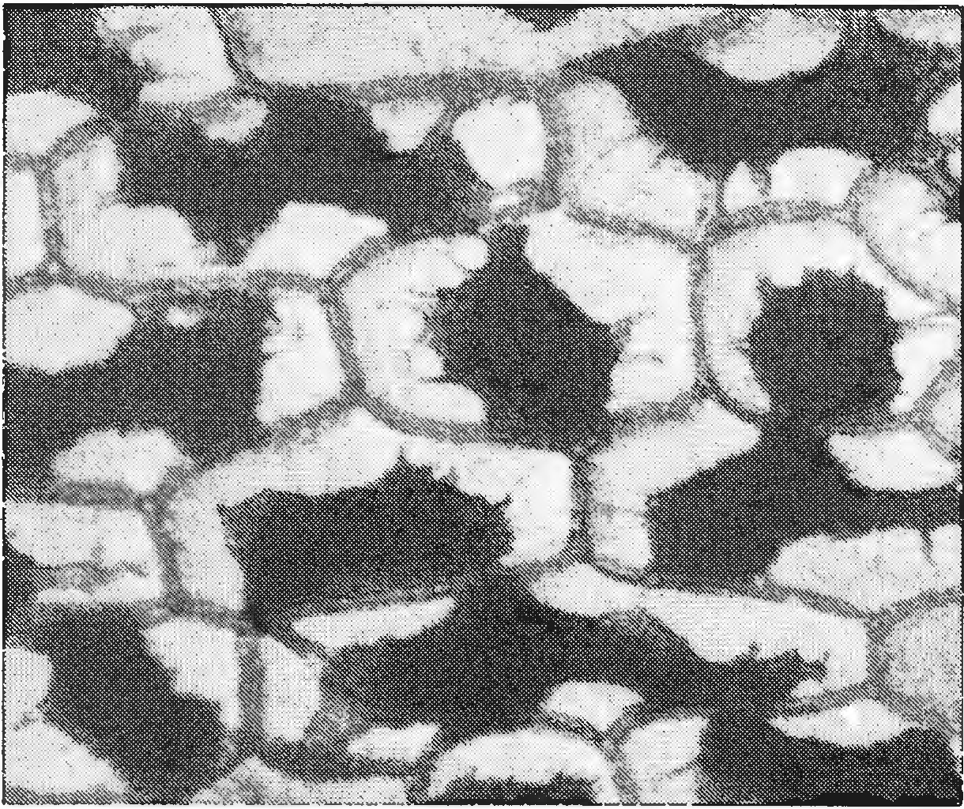

Affected plants suffer an immediate loss of water to the soil, and also cell damage that may prevent them from taking in water when conditions in the environment improve.

CMA solution
The osmotic stress caused to plants by de-icers is dependent on the number of particles in solution. CMA has a relatively large formula mass and urea is covalent. Therefore, for solutions of equal concentration by mass, CMA yields fewer particles than salt and would be expected to be less destructive. However, in this particular test, the difference is not very significant and students will observe similar effects with both de-icers. This makes a good topic for discussion on the reliability and interpretation of observations (see below).
CMA is alkaline in solution. Students may observe that the red pigment from the ruptured cells turns green, an effect that is particularly noticeable if the solution of CMA is freshly prepared. Classes that have experience of plants as sources of indicator dyes may be able to interpret this observation without help.

Caution in interpreting the results
This experiment shows the effect that de-icers may have on plant cells. It does not prove that the damage is permanent. Students may interpret the results as showing that any de-icer may affect roadside plants. If time is available, the teacher may wish to discuss with students the difficulties encountered in interpreting results.
A more scientific study would test whether or not the cells can recover when the osmotic stress is gradually relieved by placing the cells in solutions of lower and lower concentrations of de-icer. It is the concentration of de-icer at which the damage becomes irreversible that is most significant.
CMA is a development towards 'greener' de-icers. The ethanoate (acetate) ion in CMA is biodegraded to form water and carbon dioxide by soil micro-organisms and so the osmotic stress is relieved between 2 and 14 days after application (depending on the temperature). Whereas salt de-icer accumulates in the soil.

Which de-icer is best to use in urban environments where plants are present?
Students carrying out this investigation might be expected to choose CMA as a de-icer for use in locations such as a tree-lined road.
When considering the additional cost of the CMA, the team as a whole may decide that the planting of trees that are resistant to salt is a more cost-effective alternative to using expensive but less toxic de-icers.
Other options that might be suggested by students could include the use of tree guards to attempt to shield trees from the mixture of snow and de-icer that is cleared to the side of the road and tends to pile up around the base of tree trunks.
Students are unlikely to think of the use of anti-transpirants to spray onto shrubs that are vulnerable to salt spray thrown up by passing vehicles. Anti-transpirants have been tried, with limited success, since the closure of stomata on leaves helps to reduce damage due to salt spray. The analogy with anti-perspirants may interest students if there is time to raise these issues in a final class discussion.

Best de-icer near roadside plants
Damage to road-side plants is due to de-icer that affects the plant cells.
You will investigate how the de-icers affect the water inside the plant cells.

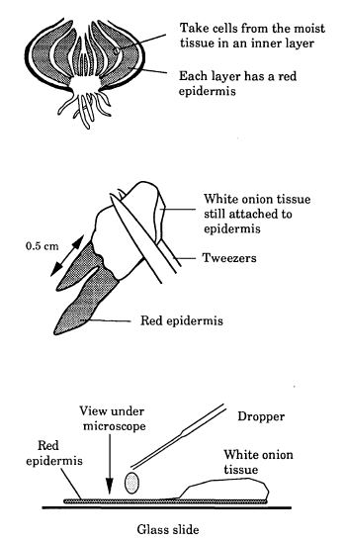
Preparing microscope slides of plant cells

Break open a red onion to reveal the outer layer of one of the sections.
Use a pair of tweezers to pull a thin layer of the red epidermis (skin) from the inner surface.
The aim is to get a thin layer that is just one cell thick. Try not to let the layer fold over on itself.
Place the epidermis onto a glass slide.
Add one or two drops of distilled water onto the sample. Use filter paper to clear excess liquid.
View the thinnest part of the epidermis under the microscope using low magnification (x4 lens) at first.
See how the cells are full of red sap. Some may be empty but these are cells that were broken open when you peeled back the epidermis.
Draw a diagram to show the cells in this control slide.

Your task
Which is the best de-icer to use near roadside plants?
Prepare a second slide using a solution of salt de-icer in place of the distilled water. View this slide under the microscope. Observe for several minutes to see if de-icer has any effect on the plant cells.
Draw a diagram to show what happens.
Label your slide with the name of the de-icer.
Observe the effect of the second de-icer.

Explain your investigation and your conclusions to the rest of your team.

Activity 3: Comparison of effectiveness
The activity compares the effectiveness of different de-icers by measuring the amount of ice melted by equal masses of different de-icers under controlled conditions.
Other factors are important and a more complete investigation would also involve measuring how quickly a given mass of ice melts when the de-icer is added and the temperature range over which the de­icer will function. Many other methods are suitable for completing the same investigation. The solid de-icers used in this practical exercise may be recovered by evaporation and recycled for subsequent lessons.

Materials
- Access to a balance to weigh out 15 grams of each solid de-icer
- 3 x clock glass/rough paper and spatula/spoon for weighing
- Supply of crushed ice (at least 500cm³) and a 100cm³ beaker
- Pestle and mortar, stop clock or sight of clock
- 4 x polystyrene cup
- stirring rod
- 50cm³ measuring cylinder
- plastic filter funnel
- thermometer (optional)
Students should use a pestle and mortar to grind the CMA to a similar particle size to the salt. CMA is difficult to grind and students may require help.

Observations
Since individual practical work is carried out with relatively small amounts of ice at room temperature, it is possible that the amount of ice that melts in the control could be a substantial fraction of the other measurements recorded. It is therefore probably best to avoid apparatus that has a relatively high thermal capacity, such as glass. The experiment is best carried out in expanded polystyrene cups or polystyrene cups on an insulating base (for example, newspapers). The use of plastic filter funnels is also suggested.
Students may suggest that the control should also include 15 g of insoluble solid, or they may question the validity of an experiment carried out at room temperature.
Students could be asked to consider if the differences in performance of de-icers are significant.

Which is the best de-icer: CMA or salt?

How much ice melts in 10 minutes?
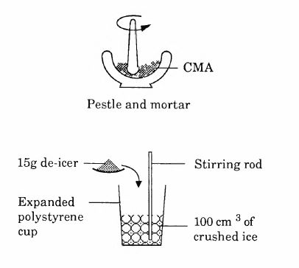

The CMA de-icer will first need to be powdered.
Wear eye protection
Weigh out 15g of each de-icer.

Have this apparatus ready for each de-icer.
Use a 100cm³ beaker to put 100cm³ of crushed ice into each polystyrene cup.
Set up a control as well.

Add the de-icer to the ice in the plastic cup.
Start the stop clock.

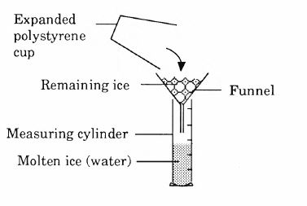
Stir the cups often. Make sure the de-icer does not collect at the bottom of the cups.
Stir the control just as much as you stir the other cups.

After 10 minutes, pour the contents of each cup into a funnel.
Measure the volume of water.
This gives the amount of ice that has melted in each cup.

Which is the best de-icer: CMA or salt?
Present your results in a table and decide which is the best de-icer.
How will you handle the results from the control (no de-icer)?

Be prepared to explain your investigation to the rest of your team.

What are the best answers?
If there is time for class discussion, the teacher may wish to compare the decisions made in different teams. Teams could be asked to give reasons for their decisions.
The option of using no de-icer at all could potentially result in accidents and bring traffic to a standstill during icy periods. The option of using abrasives (sand and grit) to improve traction and to cut down salt usage is a less effective alternative as far as de-icing is concerned and abrasives also block the drains. The use of chains or studded tyres may be more appropriate in countries that have more severe winters than the United Kingdom.

De-icers and their costs
Cost is an obvious consideration when choosing a de-icer. However, it is difficult to put a monetary value on traffic delays and on environmental assets such as trees. Some ideas and some indication of current practice is offered below.
De-icer | £ per tonne | Lowest operating temperature (ºC) | Chemical formula
Salt | 25 | -21 | NaCl
CMA | 600 | -21 | CaMg(OOC.CH₃)₄

At a motorway interchange (concrete bridge structures)
CMA is a recent development in de-icers. To use any other de-icer, from the choice offered to students in this unit, would be a false economy because of the vulnerability to corrosion of the steel in the reinforced concrete structure.
Urea is a deicer used on some elevated sections of motorway, at the entrances to some tunnels, and on some major bridges in the United Kingdom.
Engineering solutions include heating the road surface, cathodic protection of the steel reinforcements, or attempting to make waterproof seals in bridge joints and around steel reinforcements so that de-icer cannot penetrate.

General roads and paths
Plants may need to be protected but typically, over large areas, salt is an effective and inexpensive de-icer. Options of using no de-icers include clearing ice and snow by hand, or using underground heating for pathways.

A tree-lined road or pathway
Salt de-icer is widely used. Students choosing CMA to protect the trees are unlikely to have considered the costs and difficulties of treating isolated areas with a different de-icer or that vehicles may not be able to spread different de­ icers. Salt will also be brought in on vehicles moving in from elsewhere.
Other options include leaving roads and paths ice-bound or planting salt resistant trees, such as oak, along with the continuing use of salt de-icer. The wide spread of roots from established trees make the idea of soil barriers unrealistic.

Other considerations
How far should an analysis extend if the best solutions are to be achieved?
Investigations did not include a consideration of the environmental impact of manufacturing each of the different de-icers, nor the impact of the de-icers that run off the roads into streams and rivers. Such considerations are in a full Life Cycle Analysis (cradle to grave analysis) of a product.
Sound scientific reasoning may not determine the outcome of decision-making because, in the case of de-icers, many of the costs involved in using them (such as road repairs) are not charged to the budget of those responsible for making decisions.
CMA is so expensive, compared to salt, because of the different methods of manufacture. CMA must be synthesized at a manufacturing plant from ethanoic acid and oxides produced by heating dolomite rock. Salt is inexpensive because it is relatively simple to mine.

Other investigations
Students could be asked to suggest other investigations that ought to be carried out in order to get a true understanding of the merits or disadvantages of the different de­ icers and what precautions they would suggest to minimize any negative effects of their chosen preference.
Particularly on the steep approaches to bridges and river crossings, the effect that de­icers have on the adhesion between tyre and road surface is an important consideration. Students might offer plans to test friction at surfaces treated with different de-icers.
The impact of de-icer that runs off roads with rain water and then drains into streams and rivers, or de-icer that leaches into water supply aquifers, is important. The effects on aquatic life and on drinking water supplies must be investigated if a complete analysis is to be achieved.

